


ICTPRG432 Develop data-driven applications

ICTPRG433 Test software developments

ICTPRG430 Apply introductory object-oriented language skills

Learner version

Assessment task 2
Develop data-driven apps
Disclaimer: This resource was developed by Holmesglen Institute of TAFE in 2024 for the State of Victoria (Department of Education and Training) for educational purposes, is © State of Victoria (Department of Education and Training) and is available under a Creative Commons Attribution Non-commercial 4.0 International (CC BY-NC 4.0) license.
The license does not apply to: Trademarks or branding, including the Victorian Government logo and any unattributed content supplied by third parties




Learner version

Assessment task 2
Develop data-driven apps

Learner information
Learner name: Insert name | Learner ID: Insert ID

Section A – Program/course details
Qualification code: ICT40120 | Qualification title: Certificate IV in Information Technology (Programming)
Unit code:  CPRO2 Data Driven Programming  ICTPRG432  ICTPRG433  ICTPRG430 | Unit title:  Develop data-driven applications  Test software developments  Apply introductory object-oriented language skills
Pre/co-requisites: N/A

Section B – Assessment task details
Assessment number: 2 of 2 | Semester/year: 1/2026 |  | Due date: Session 17
Duration of assessment: 14 Sessions |  | Assessment task results: This assessment task will be marked as:  ☒ Ungraded result: satisfactory or not yet satisfactory

Section C – Instructions to learners

Assessment task description:
This assessment is comprised of 3 parts.
Part 1: Knowledge questions
Part 2: Develop a 2D-Shapes Calculator
Part 3: Develop “ToDo” List

Part 2 also covers software testing, including both manual and automated testing. It provides instructions to:
- Identify unit test requirements (including the test framework)
- Identify system test requirements
- Explore test-case design techniques
- Develop a test plan
- Validate the test results with a member of the software development team
- Learners are required to answer all questions correctly and to a satisfactory level. If this is not achieved on the first attempt, a resubmission will be required.
- You must demonstrate the application (Part 2, Part3) on the assessment due date. You may choose to present it either in a breakout session or during the class.
- Once learners have completed all the questions, the assessment must be uploaded and submitted along with the signed assessment coversheet via Brightspace.
- Please check your spelling and grammar before submitting the final version to the assessor.
- If you require special consideration or adjustments, discuss your needs with your assessor.
- You may consult:
- Class learning materials on Brightspace
- Other soft copy resources
- Reliable online sources
- However, all responses must be written in your own words. If you include direct quotes, you must cite the original source.
- Your completed assessment must be uploaded to Brightspace along with a completed and signed coversheet by the due date.
- Submit all required working files, documentation, and supporting materials in a zipped folder, including the signed coversheet.
- If you are unable to submit by the due date, you must obtain written approval from your assessor for alternative submission arrangements.
- Learners must adhere to organisational policies and standards, including those related to:
- Intellectual property
- Privacy laws
- Plagiarism and academic honesty
Further details are available at https://holmesglen.edu.au/Students/Student-Resources

Section D – Conditions for assessment

Unit application:
- This is an individual task.
- You must meet all criteria listed in the marking guide to be satisfactory in this task.
- You must submit all required working files, documentation, and any other assets that you feel may be required in a zipped file, including the completed and signed coversheet. The assessment must be completed and submitted electronically to Brightspace by the due date. If this is not possible, you must contact your assessor to gain written approval for an alternative arrangement for submitting the assessment.
- If not successful within the enrolment period as per Holmesglen assessment procedure, you will be requested to resubmit within 7 days of receiving feedback. You will have the opportunity to resubmit if any part of the assessment is deemed unsatisfactory (you are permitted TWO (2) resubmission per assessment task). Resubmissions must be submitted by the resubmission due date provided by your teacher.
- This task is open book. You may use the internet for research purposes only. All answers must be in your own words. Where a quote is used, you must cite the information source.
- If you feel you require special allowance or adjustment to this task, please discuss with your assessor within one week of commencing this assessment. Any change to assessment arrangements must be reviewed by the Education Manager and approved by the Head of Department.
- You can appeal an assessment decision according to the Holmesglen Assessment Complaints and Appeals Procedure.
- You are expected to dedicate time to develop this assessment task both in and out of the classroom.
- Leaner must contribute to and abide by organisational standards including intellectual property, privacy laws, and plagiarism and academic honesty. Further information is detailed at: https://holmesglen.edu.au/Students/Student-Resources
- Use of Generative AI Tools in Assessments
You are permitted to use generative AI tools to support your research and development process for this assessment. This aligns with the broader educational focus on digital literacy and emerging technologies. However, your use of these tools must be transparent, responsible, and in accordance with academic integrity standards.

You must not use generative AI to:
- Generate full-text responses for written assessment questions.
- Write complete scripts or presentations without your own input.
- Produce entire data sets, budgets, or analytical outputs without demonstrating your own understanding.

Your use of these tools should be to support your work, not to replace it. This includes tasks such as:
- Brainstorming ideas.
- Conducting preliminary research.
- Structuring your presentation.
- Editing and refining your written work.

Academic Honesty and Plagiarism
Any use of AI tools must be clearly acknowledged. For example, you can include a note such as:
“Generative AI was used to assist with brainstorming and editing.”
Failure to follow these guidelines may be considered academic misconduct under Holmesglen’s policy.

Equipment/resources learners must supply: | Equipment/resources to be provided by the RTO:
Learners opting to BYOD laptop or intending to learn remotely will require access to: | This is a blended learning course and as such a remote learner will access their own computer equipment as per the specification provided. The Institute will provide the following:
A MAC or PC/laptop with the following minimum specification:  • Quad-Core CPU, 16GB of RAM, 250GB of Storage, 2 GHz or faster processor  • Windows 10 OS, or virtual machine installed with Windows 10 OS (available free from https://developer.microsoft.com/en-us/windows/downloads/virtual-machines/ or https://www.microsoft.com/en-us/evalcenter/evaluate-windows-10-enterprise)  • Headset with microphone and webcam  • Internet access  Applications access available through Holmesglen MyHorizon and free access which can be downloaded via link below:  • Brightspace (Learning Management System) - https://holmesglen.brightspace.com/  • 365 Microsoft office suite - https://portal.office.com  • WebEx - https://holmesglen.webex.com/  • Holmesglen OneDrive  • Google Chrome – recommended web browser  • 7-Zip - https://www.7-zip.org/download.html  • Microsoft Office  • Lucid chart via internet  • Microsoft Visual studio Enterprise/community edition 2017/19/21/22 or latest version available in the market with C# components installed as a language  • SQLite DB Browser – free to download  USB drive/External hard drive / cloud storage to save project work | Holmesglen computer classrooms:  - data projector, whiteboard, computer with double screens, mobile Cisco Spark Board, Conference camera  HP Z1 Entry Tower G5  • Dual Displays 24” HP Monitor  • CPU: Intel Core i7-9700K @ 4GHz  • Motherboard: 8591  • RAM 32GB  • 1TB SSD  • OS: Windows 10  iMAC  • iOS Catalina 10.15.7 (19H1713)  • 27" Retina 5K  • Processor: 4GHz Quad-Core Intel Core i7  • Memory: 16GB 1867 MHz DDR3  This will vary as CAIT upgrades computer rooms.  • Internet connection  Applications access available at ZENworks and Holmesglen MyHorizon:  • Brightspace (Learning Management System)  • 365 Microsoft office suite  • Lucid chart  • WebEx  • Google Chrome – recommended web browser  • 7Zip  • Applications:  • Microsoft Office  • WebEx - free to download  • Microsoft Visual studio Enterprise/community edition 2017/19/21/22 or latest version available in the market with C# components installed as a language  • SQLite DB Browser  * All are licensed

Section E – Assessment questions/criteria
Assessment number: 2 | Assessment title: Develop data-driven apps
Learner name: Insert name |  |  | Learner ID: Insert ID
Unit code:  CPRO2 Data Driven Programming  ICTPRG432  ICTPRG433  ICTPRG430 |  | Unit title:  Develop data-driven applications  Test software developments  Apply introductory object-oriented language skills
Date: Insert date

Part 1 – Knowledge Questions (Written Response)
 | AI Assisted Learning Permitted | Guided Use
 | You may use AI tools to help research, clarify concepts, or check your understanding. However, your final response must demonstrate your own application and comprehension.

Provide your responses in the boxes below each question.

Question | Satisfactory response
What is a class and constructor in Object Oriented Programming (OOP)  - Discuss the advantages of classes  - How do classes benefit software development | Yes ☐ No ☐
Answer: | Comment:

Question | Satisfactory response
What is Object Aggregation (the “is-a” or “part-of”). You may use an example to explain. | Yes ☐ No ☐
Answer: | Comment:

Question | Satisfactory response
Discuss the 3 basic programming structures, sequential, condition, loop which can be implemented through Object oriented data structure called class. | Yes ☐ No ☐
Answer: | Comment:

Question | Satisfactory response
What is member field and member method in a C# class  Note member field can be a primitive instance variable and member method is also refer to as instance method in some other languages | Yes ☐ No ☐
Answer: | Comment:

Question | Satisfactory response
What is static member field and static member method in a C# class  Note static member field is also referred as class variable and static member method is also refer to as class method in some other languages | Yes ☐ No ☐
Answer: | Comment:

Question | Satisfactory response
Discuss the debugging and testing approaches and techniques in software development | Yes ☐ No ☐
Answer: | Comment:

Question | Satisfactory response
What is the Software Development Life Cycle (SDLC), and why is it important in software development? Describe the key phases involved and explain how each phase contributes to the successful creation of software. | Yes ☐ No ☐
Answer: | Comment:

Question | Satisfactory response
List and describe common types of documentation used in the Software Development Life Cycle (SDLC). For each type, explain its purpose and how it supports the development process | Yes ☐ No ☐
Answer: | Comment:

Question | Satisfactory response
Discuss the typical development process for small-size software applications. What steps are usually involved, and how might they differ from those used in large-scale projects? | Yes ☐ No ☐
Answer: | Comment:

Question | Satisfactory response
Discuss the testing processes, tools, and techniques commonly used for small-size software applications. How do these ensure the application works correctly and meets user needs? | Yes ☐ No ☐
Answer: | Comment:

Question | Satisfactory response
Research industry standard auto test frameworks for the following languages | Yes ☐ No ☐
Answer: | Comment:

Question | Satisfactory response
Describe the software testing concept of IPO (Inputs, Process, Outputs). How can this model be used to design and test applications effectively? | Yes ☐ No ☐
Answer: | Comment:

Question | Satisfactory response
Explain the following data structure - array, tree | Yes ☐ No ☐
Answer: | Comment:

Question | Satisfactory response
Discuss at least 5 organisational guidelines and procedures applicable to software development and testing frameworks | Yes ☐ No ☐
Answer: | Comment:

Question | Satisfactory response
Discuss software defect management process | Yes ☐ No ☐
Answer: | Comment:

Question | Satisfactory response
Discuss relational database management systems, functions and tools.  You may use any database management systems you have used for discussion. For example MS SQL Server, SQLite DB Browser, PHPMyAdmin … | Yes ☐ No ☐
Answer: | Comment:

Question | Satisfactory response
Discuss the concept of application programming interfaces. What is operation system API, libraries API, web API? | Yes ☐ No ☐
Answer: | Comment:

Question | Satisfactory response
Research and discuss at least three different data providers or access technologies that allow programs to connect and interact with databases. For each one, explain the vendor or technology, what type of databases it connects to, and how it is used in programming (e.g., ADO.NET/ Entity Framework, ODBC, PDO). | Yes ☐ No ☐
Answer: | Comment:

Question | Satisfactory response
What are the core principles of Structured Query Language (SQL)? Explain how these principles guide the way data is stored, managed, and accessed in a relational database. | Yes ☐ No ☐
Answer: | Comment:

Question | Satisfactory response
What are the organisational guidelines and procedures applicable in assisting the development of data-driven applications? | Yes ☐ No ☐
Answer: | Comment:

PORTFOLIO
 | AI Assisted Learning Permitted | Guided Use
 | You may use AI tools to help research, clarify concepts, or check your understanding. However, your final response must demonstrate your own application and comprehension.

Criteria for assessment | Satisfactory  Yes No | Comment
The following has been submitted for assessment:
Part 1 - Knowledge questions | ☐ ☐
Part 2 – Develop a 2D-Shape Calculator | ☐ ☐
Part 3 – Develop a “ToDo” List | ☐ ☐
Marking criteria for each product/ document supplied.
Part 1 - Knowledge questions
- Learner correctly discussed class and constructor. | ☐ ☐
- Learner correctly discussed object aggregation | ☐ ☐
- Learner correctly discussed basic programming structures, sequential, condition, loop which is implemented through Object oriented data structure called class | ☐ ☐
- Learner correctly discussed member field and member method in a C# class which contains primitive instance variables | ☐ ☐
- Learner correctly discussed static member field and static member method in a C# class | ☐ ☐
- Learner correctly discussed the debugging and testing approaches and techniques in software development | ☐ ☐
- Learner correctly discussed software development life cycle | ☐ ☐
- Learner correctly listed common organizational documentation types and their purposes in SDLC | ☐ ☐
- Learner correctly discussed small-size application development processes | ☐ ☐
- Learner correctly discussed the processes, tools and techniques for testing small-size applications | ☐ ☐
- Learner correctly researched auto test frameworks for the following languages such as C# | ☐ ☐
- Learner correctly described software test concept “IPO” (Inputs, Process and Outputs) | ☐ ☐
- Learner correctly explained the following data structure - array, tree | ☐ ☐
- Learner correctly discussed at least 5 organisational guidelines and procedures applicable to software development and testing frameworks | ☐ ☐
- Learner correctly discussed software defect management process | ☐ ☐
- Learner correctly discussed relational database management systems, functions and tools | ☐ ☐
- Learner correctly discussed the concept of application programming interfaces. | ☐ ☐
- Learner researched and discussed at least 3 different data providers and vendors | ☐ ☐
- Learner correctly discussed the principles of Structured Query Language (SQL) | ☐ ☐
- Learner correctly discussed the organisational guidelines and procedures applicable in assisting the development of data-driven applications | ☐ ☐
Marking criteria for each product/ document supplied.
Part 2 – Develop a 2D-Shape Calculator
1.1. Learner read the project brief for this application, review and clarify user requirements with user. And list all user requirements using bullet points. | ☐ ☐
1.2. Learner plan and determine the class hierarchy (inheritance tree) and numerical computations are done as per user requirements | ☐ ☐
1.3. Learner plan and determine the member fields and methods for all classes. | ☐ ☐
1.4. Learner explained “inheritance”, “polymorphism” and “overriding methods”. | ☐ ☐
1.5. Learner implemented all classes according to the design above using an OOP programming language (e.g. C#). | ☐ ☐
1.6. Learner implemented two versions of constructors for all classes with member fields and ensure at least implemented one sequence, one selection and two iteration constructs and two arrays of primitive data types in the application. | ☐ ☐
1.7. Learner implemented the console user interface according to the requirements which consists of at least 3 coding conventions. | ☐ ☐
Marking criteria for each product/ document supplied.
Part 3 – Develop Data-driven Applications
3.1. Learner read the project brief for this application, review and clarify user requirements with user. And list all user requirements using bullet points. | ☐ ☐
3.2. Learner plan and determine the class hierarchy (inheritance tree) which embeds the object-oriented features to satisfy user requirements. | ☐ ☐
3.3. Learner plan and determine the member fields and methods for all classes. | ☐ ☐
3.4. Learner explained “inheritance”, “polymorphism” and “overriding methods”. | ☐ ☐
3.5. Learner implemented all classes according to the design above using an OOP programming language (e.g. C#). | ☐ ☐
3.6. Learner implemented two versions of constructors for all classes with member fields | ☐ ☐
3.7. Learner implemented the console user interface according to the requirements | ☐ ☐
3.8. Learner research disconnected data management strategy | ☐ ☐
3.9. Learner read and write files using programming language | ☐ ☐

Supporting document: Develop a 2D-Shapes Calculator

Part 2 - Develop a 2D-Shapes Calculator

Development requirements

Here are the requirements for the “2D-Shapes Calculator” program.
1 | User is able to use a command line-based console interface to operate the calculator.
2 | User is able to choose the target shape from a predefined list, including square, rectangle, circle, trapezoid.
3 | User is able to choose what to calculate for each selected geometry shape from a predefined list, including area and perimeter.

You are required to
- Design and develop a software program that meets the above requirements
- Develop a test plan that covers the requirements using provided template
- Execute the test plan to verify the program
- Generate a test report using provided template

You are also required to follow the questions in the step 1 and step 2 below to finish all the tasks and answer all the questions.

Development environment
- Visual studio
- SQLite DB-browser

Organisational guidelines
- C# Coding Conventions - https://docs.microsoft.com/en-us/dotnet/csharp/fundamentals/coding-style/coding-conventions
- Software test principles and guidelines. See attached file below.

Step 1 – Software design & development
In this step, you are required design and develop the application using a selected programming language (e.g. C#).
1.1. Read the project brief for this application, review and clarify user requirements with user. And list all user requirements using bullet points.
Answer:

Requirements in brief ( I would like to assess your understandings of specifications)

1.2. Plan and determine the class hierarchy (inheritance tree) to satisfy user requirements. You are required to use the following notation to represent the inheritance relationship.

Answer:
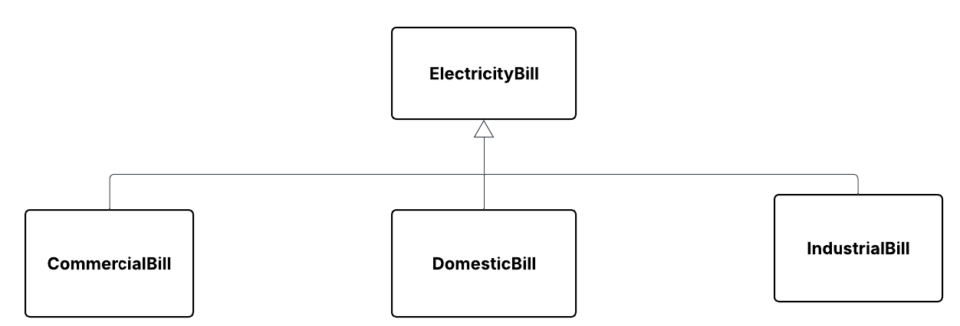
1.3. Plan and determine the member fields and methods for each class documented in question 2 above. You are required to use the following notation to represent a class.

Answer:
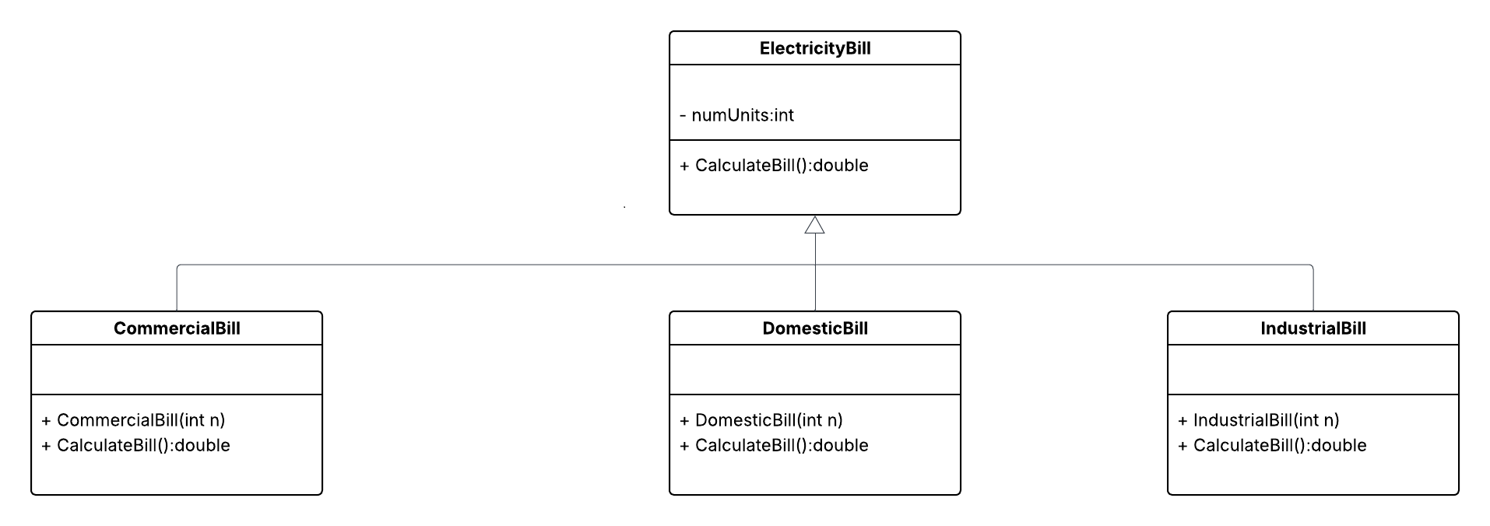
1.4. In terms of object-oriented programming, explain “inheritance”, “polymorphism” and “overriding methods”. You may explain the three terms by using an example.
Answer:
Terms | Your answers
inheritance | Explain briefly with a “tiny’ example
polymorphism | Explain briefly with a “tiny’ example
overriding methods | Explain briefly with a “tiny’ example

1.5 Implement all classes according to the design above using an OOP programming language (e.g. C#, in Visual Studio IDE). You need to make sure:
- Inheritance and polymorphism (overriding methods) have been correctly implemented.
- Code conventions are followed
- Codes are fully documented using comments
Provide a screenshot of the codes for each class definition.
Answer:
ElectricityBill | 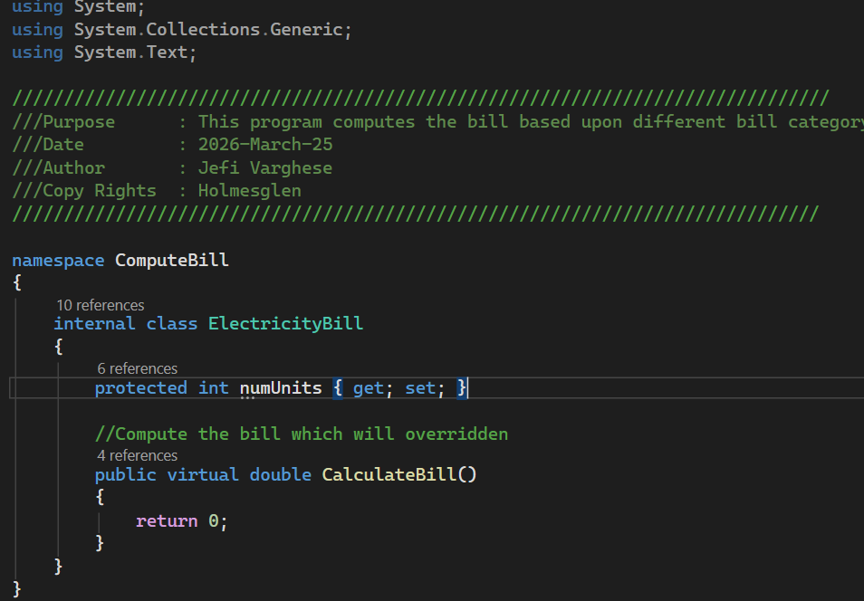
DomesticBill | 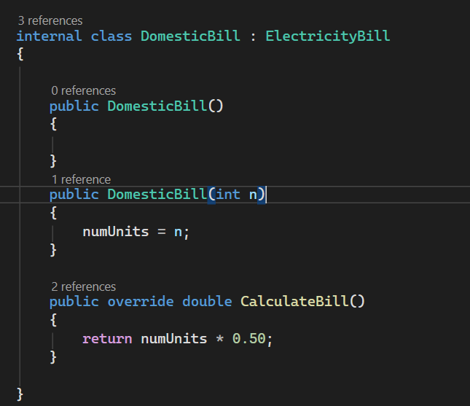
IndustialBill | 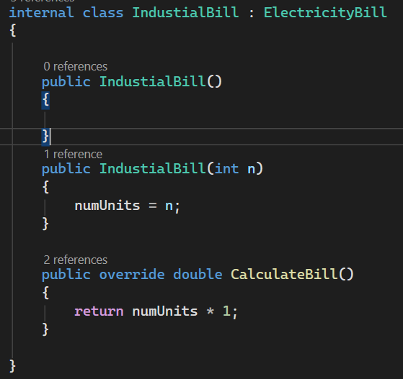

Add more rows as you need in the table above to cover all classes.

☒ I have followed code conversions
☒ I have fully documented using comments

1.6 Implement two versions of constructors for all classes with member fields.
- One constructor accepts zero parameter and initialize each member fields to a reasonable default value.
- The other constructor accepts a number of parameters for initializing all member fields.
Provide a screenshot of the two constructors for each class.
Answer:
Class Name | Constructor #1 – without parameter  Screenshot | Constructor #2 – with parameter  Screenshot
DomesticBill | 
IndustrialBill | 

Add more rows as you need in the table above to cover all classes.
1.7 Implement the console user interface according to the requirements. Provide a screenshot of the codes.
You need to make sure:
- Code conventions are followed
- Codes are fully documented using comments
Answer:
Your screenshot

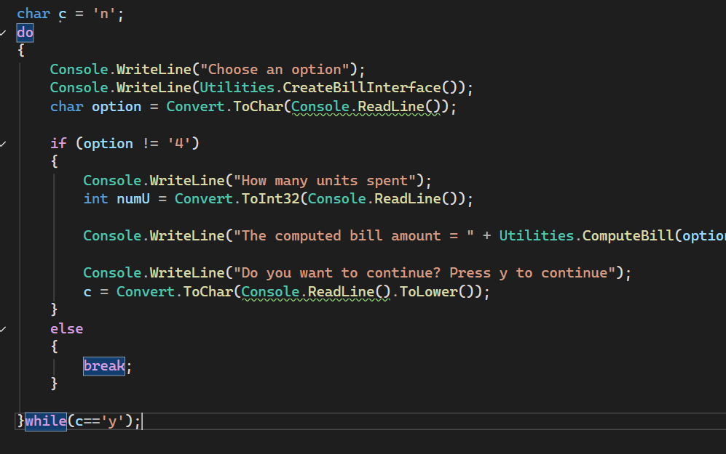
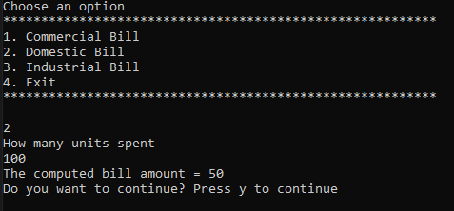

☒ I have followed code conversions
☒ I have fully documented using comments

PART 2 - OBSERVATION

Below are the observation components that the learner is required to demonstrate as part of this assessment. The learner only needs to demonstrate2 this once. If the learner is unable to demonstrate one or more of the required Observation tasks to a satisfactory level, they will be given two opportunities to demonstrate the unsatisfactory Observation task(s).
Marking criteria: Skills to be observed during this task to the required standard
In this assessment task you will be performing following activities | Date 1  Satisfactory  Yes No | Date 2  Resubmission  if applicable  Satisfactory  Yes No | Date 3  Resubmission if applicable  Satisfactory  Yes No | Comment

Develop a 2D-Shape Calculator
1.8. Learner implemented polymorphism for code extensibility | ☐ ☐ | ☐ ☐ | ☐ ☐
1.9. Learner applied documentation conventions and documented the application according to organisational documentation conventions | ☐ ☐ | ☐ ☐ | ☐ ☐
1.10. Learner applied code conventions to organisational requirements | ☐ ☐ | ☐ ☐ | ☐ ☐
1.11. Learner communicated relationships between ideas and information, in a style appropriate to the audience and purpose, and selects the vocabulary, grammatical structures and conventions appropriate to the text, in relation to coding, recording outcomes, and documenting activities. | ☐ ☐ | ☐ ☐ | ☐ ☐
1.12. Learner selected from, and flexibly applies, mathematical and problem-solving strategies and techniques, in a programming context | ☐ ☐ | ☐ ☐ | ☐ ☐
1.13. Learner recognised and followed, explicit and implicit standard and meets expectations associated with own role when developing code that is compliant with standards and guidelines | ☐ ☐ | ☐ ☐ | ☐ ☐
1.14. Learner demonstrated a deliberate decision-making method, weighing various alternatives against specific criteria to select the most appropriate data types, operators, and expressions. | ☐ ☐ | ☐ ☐ | ☐ ☐
1.15. Learner evaluated the effectiveness of decisions, in terms of how well they meet the stated design specifications | ☐ ☐ | ☐ ☐ | ☐ ☐
1.16. Learner used analytical processes to decide on a course of action when debugging | ☐ ☐ | ☐ ☐ | ☐ ☐
1.17. Learner utilised features within applications in order to develop software programs that involve mathematical equations. | ☐ ☐ | ☐ ☐ | ☐ ☐
1.18. Learner recognised, and used language and symbols, when applying the coding syntax | ☐ ☐ | ☐ ☐ | ☐ ☐
1.19. Learner actively identified systems, devices and applications with the potential to meet current and future needs regarding programming | ☐ ☐ | ☐ ☐ | ☐ ☐
1.20. Learner reviewed application against user requirements to ensure user requirements are satisfied | ☐ ☐ | ☐ ☐ | ☐ ☐
1.21. Learner presented application to user and obtain user acceptance | ☐ ☐ | ☐ ☐ | ☐ ☐

Step 2 – Software test
2.1 Identify unit test requirements for each class and list all requirements with bullet points.
Answer:

The following tests cases to be written in Test Plan and execute the testcases on “date’ and get the Test Report.

Industry Bill test
- Test Functional Unit Test boundary test,
- Equivalent partition,
- Stress test,
- Function test case

Domestic bill
- Test Functional Unit Test boundary test,
- Equivalent partition,
- Stress test,
- Function test case

Commercial bill
- Test Functional Unit Test boundary test,
- Equivalent partition,
- Stress test,
- Function test case

2.2 Identify system test requirements for the application and list all requirements with bullet points
Answer:

Console Interface Requirements
- The system shall provide a command-line (console-based) interface for user interaction.
- The system shall display clear menu options and prompts to guide the user.
- The system shall accept user input via the keyboard.
- The system shall display results and error messages in the console.

Bill Selection Requirements
- The system shall allow the user to select a Bill from a predefined list.
- The predefined list of available shapes shall include:
  - Domestic
  - Commercial
  - Industrial
- The system shall prevent selection of shapes outside the predefined list.
- The system shall prompt the user again if an invalid bill selection is entered.

Calculation Selection Requirements
- The system shall allow the user to choose what to calculate for the selected shape.
- The calculation options shall include:
  - industrial
  - domestic
- The system shall only display calculation options relevant to the selected shape.
- The system shall reject invalid calculation choices and request valid input.

Input Handling Requirements
- The system shall prompt the user to enter all required dimensions for the chosen bill and calculation.
- The system shall validate that all numeric inputs are:
  - Present
  - Numeric
  - Greater than zero
- The system shall display appropriate error messages for invalid or missing input.
- The system shall allow the user to re-enter values after invalid input.

Workflow and Usability Requirements
- The system shall allow the user to perform multiple calculations without restarting the application.
- The system shall allow the user to exit the application gracefully.
- The system shall not crash or terminate unexpectedly during normal operation.

Error Handling Requirements
- The system shall handle invalid menu selections gracefully.
- The system shall handle invalid numeric input without crashing.
- The system shall provide meaningful error messages to the user.

2.3 Discuss and confirm the above development requirements with a member in software development team.
Note: The member in software development team can be role played by another student. You are required to discuss the following items in the meeting.
Answer:
Participants/roles | Tester / QA Engineer (Student) – Responsible for designing and executing test cases  Software Developer (Role-played by another student) – Responsible for implementing the calculator application  Project Representative – Confirmed requirements and testing expectations
Meeting date | 31 March 2026
Scope of test | The following scope of testing was agreed upon during the meeting:  Included in scope  - Testing of the command-line console interface  - Verification of user ability to:  - Select a bill  - Validation of user input (numeric values, positive numbers)  - Verification of correct calculation results  - Error handling for invalid user inputs  - End-to-end system behavior
Types of tests | Unit Testing – To verify individual calculation methods for each shape  Functional Testing – To verify the complete application flow from user input to output  Boundary and Equivalence Testing – To validate input ranges and representative values Negative Testing – To ensure correct handling of invalid input
Tools | Microsoft Visual Studio  Windows Command Line  MSTest Framework
Benefits | Microsoft Visual Studio  Microsoft Visual Studio provides an integrated development and testing environment that allows developers and testers to write, run, and debug code efficiently. Its built-in testing features and error diagnostics help identify defects early in the development process, improving software quality.  Windows Command Line  The Windows command line allows realistic testing of the console-based application in the same environment used by end users. This ensures that user input handling, prompts, and outputs function correctly in real execution conditions.  MSTest Framework  MSTest supports automated unit testing and provides clear test results and assertions. It enables repeatable, reliable testing of calculation logic and helps ensure that changes to the code do not introduce new defects.

2.4 Identify organisational guidelines and frameworks related to testing. List them all using bullet points
Answer:

Software Development Life Cycle (SDLC) Policy –
Agile, Waterfall, or DevOps methodology as defined by the organisation

Coding Standards and Conventions - A set of rules for writing clean, consistent, and readable code.

Testing and Quality Assurance (QA) Procedures - Ensures software is reliable, functional, and meets user requirements before release.

2.5 Discuss at least three test-case design techniques and explain how they are applied in your test case design.
Answer:
Test-case design technique #1
Discuss this technique

. Functional Unit Test

Explain how you apply this technique in your test case design
Step 1. My expected output =100
Step 2. Create an object of electricity bill type overridden by IndustrialBill
Step 3. Call the CalculateBill and get the actual output
Step 4. Verify expected output and actual output

Test-case design technique #2
Discuss this technique

Equivalence Partitioning

Boundary value test
Explain how you apply this technique in your test case design

Write the steps
Step 1. My expected output =-1
Step 2. Create an object of electricity bill type overridden by IndustrialBill
Step 3. Call the CalculateBill and get the actual output
Step 4. Verify expected output and actual output

Test-case design technique #3
Discuss this technique

Stress test

Explain how you apply this technique in your test case design

Step 1. My expected output =100000
Step 2. Create an object of electricity bill type overridden by IndustrialBill
Step 3. Call the CalculateBill and get the actual output
Step 4. Verify expected output and actual output

2.6 Develop test plan and test cases using provided template.
You are required to apply the test-case design techniques discussed above and develop TWO test cases with EACH technique.
Write the submitted test plan file name in the answer box below.
Answer:

2.7 Develop unit test procedures using an auto testing framework (e.g. Visual Studio Unit Testing). Provide a screenshot of the unit test codes (if the codes are too long, screenshot 2 test case for this question and your teacher will check all the codes in your code submission).
Answer:

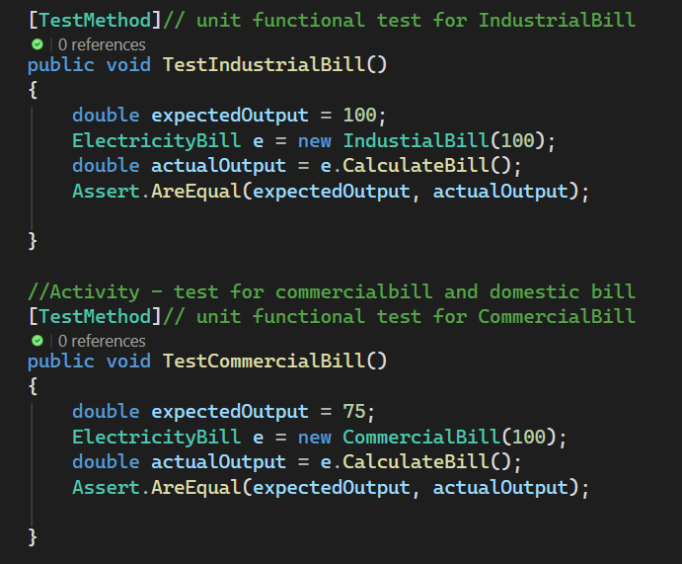
2.8 Perform manual test according to system test plan, screenshot the test results (for at least two test cases).
Answer:

Test Case ID: TC_001
Objective: Computation of domestic bill is one.
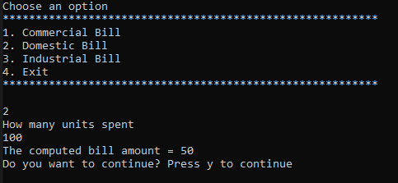

Test Case ID: TC_002
Objective: Computation of CommercialBill is one
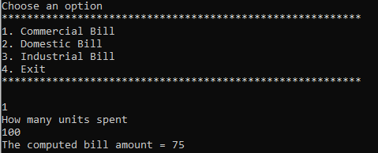

2.9 Perform auto test according to unit test plan, screenshot the test results (for at least two test cases).
Answer:

Test Case 1: DomesticBill
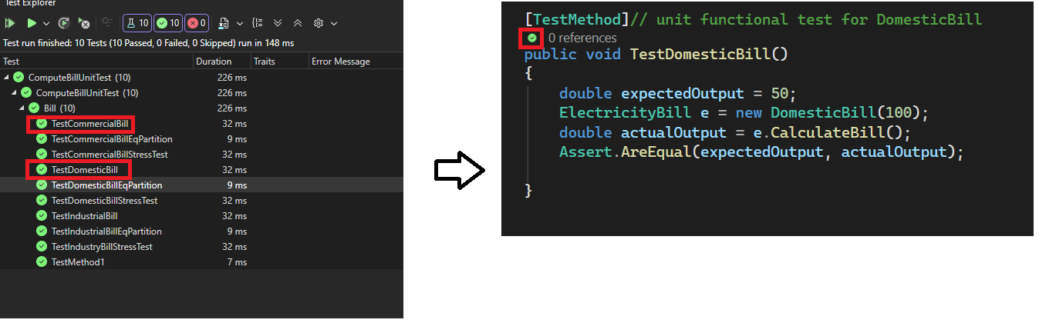

Test Case 2: CommercialBill
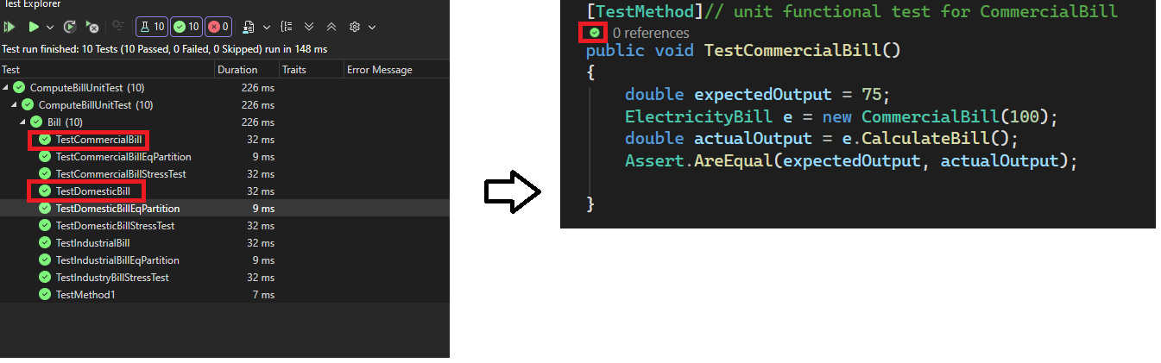

2.10 Discuss and confirm the above test results with a member in software development team.
Note: The member in software development team and be role played by another learner.
Answer:
Participants/roles | Project Engineer
Meeting date | 01/Apr/26
Meeting minutes | Summary of the meeting.

2.11 Produce and save test reports using provided template.
Write the submitted test plan file name in the answer box below.
Answer:

2.12 Manage defects and review software, amending further defects. You are required to record how did you managed defect for at least one issue based on the test results using the template below.
Answer:
Issue description
Test Case ID
ST-BILL-NEG-01
Defect Title / Description
Incorrect handling of zero and negative unit input in bill calculation returns incorrect result message and value.

Steps to Reproduce
- Launch the console-based electricity bill calculator.
- Select Commercial / Industrial Bill calculation.
- Enter the number of units as 0 or a negative value (e.g., -5).
- Observe the output displayed by the system.

Expected Result
- The system should display an appropriate error message indicating invalid input.
- The system should not calculate a bill amount.
- The system should return a predefined error value (e.g., -1) or request re-entry of valid input.

Actual Result
- The system calculated the bill using the invalid unit input.
- An incorrect or misleading output was displayed.
- The calculation logic did not properly prevent invalid inputs from being processed

Root Cause Analysis
The validation logic for unit input was missing or insufficient. The system allowed zero or negative unit values to pass through to the calculation logic without proper checks.

Defect Fix / Amendment
A conditional validation check was added before performing the calculation:
- If numUnits <= 0, the system:
  - Displays an error message to the user
  - Returns a safe error value
  - Prevents further calculation
Code Amendment (Summary)
Input validation logic was implemented at the beginning of the CalculateBill() method to ensure only valid unit values are processed.

Retest Result
Pass
- The system correctly identifies invalid inputs.
- The appropriate error message is displayed.
- No calculation is performed for invalid input.
- Valid inputs continue to produce correct results.

PART 2 - OBSERVATION
Below are the observation components that the learner is required to demonstrate as part of this assessment. The learner only needs to demonstrate2 this once. If the learner is unable to demonstrate one or more of the required Observation tasks to a satisfactory level, they will be given two opportunities to demonstrate the unsatisfactory Observation task(s).

Marking criteria: Skills to be observed during this task to the required standard
In this assessment task you will be performing following activities | Date 1  Satisfactory  Yes No | Date 2  Resubmission  if applicable  Satisfactory  Yes No | Date 3  Resubmission if applicable  Satisfactory  Yes No | Comment

Test 2D-Shape Calculator
2.1. Determined the unit-testing needs including test framework as per the organisational standards for every class and presented all identified items as bullet points. | ☐ ☐ | ☐ ☐ | ☐ ☐
2.2. Outlined the class-level unit-test criteria and displayed each requirement in bullet-point format. | ☐ ☐ | ☐ ☐ | ☐ ☐
2.3. Reviewed and validated these development expectations with a member of the software development team. | ☐ ☐ | ☐ ☐ | ☐ ☐
2.4. Located the organisation’s testing standards and frameworks and listed them in bullet points. | ☐ ☐ | ☐ ☐ | ☐ ☐
2.5. Examined at least three test-case design methods and described how each was utilised in creating the test cases. | ☐ ☐ | ☐ ☐ | ☐ ☐
2.6. Created the test plan and corresponding test cases using the supplied template. | ☐ ☐ | ☐ ☐ | ☐ ☐
2.7. Produced unit-test procedures through an automated testing framework. | ☐ ☐ | ☐ ☐ | ☐ ☐
2.8. Executed manual testing following the system test plan and captured screenshots of the outcomes. | ☐ ☐ | ☐ ☐ | ☐ ☐
2.9. Develop unit test procedures using an auto testing framework as a part of debugging. Ran automated tests in line with the unit-test plan and 2.1, recorded screenshots of the results. | ☐ ☐ | ☐ ☐ | ☐ ☐
2.10. Discussed and confirmed the testing outcomes with a member of the software development team. | ☐ ☐ | ☐ ☐ | ☐ ☐
2.11. Generated and stored the test reports using the provided template. | ☐ ☐ | ☐ ☐ | ☐ ☐
2.12. Handled defects and re-evaluated the software, correcting additional issues as required. | ☐ ☐ | ☐ ☐ | ☐ ☐
2.13. Learner identified test and script requirements including data structures | ☐ ☐ | ☐ ☐ | ☐ ☐
2.14. Learner analysed and identified test data using multiple test-case design techniques. | ☐ ☐ | ☐ ☐ | ☐ ☐
2.15. Learner defined and designed test cases. | ☐ ☐ | ☐ ☐ | ☐ ☐
2.16. Learner documented test plan and script according to organisational guidelines and industry standards | ☐ ☐ | ☐ ☐ | ☐ ☐
2.17. Learner designed and implemented algorithm required in test procedures | ☐ ☐ | ☐ ☐ | ☐ ☐
2.18. Learner took responsibility for planning, sequencing and prioritising tasks and own workload | ☐ ☐ | ☐ ☐ | ☐ ☐

Please use the check list below to check if you have got everything ready before submitting the assessment for review.
Part 2 - Submission check list
Assessment document with all questions answered | ☐
All source codes | ☐
Test plan document for system test | ☐
Test plan document for unit test | ☐
Test report document for system test | ☐
Test report document for unit test | ☐

Supporting document: Develop a 2D-Shapes Calculator

Part 3 – Develop “ToDo” List

Scenario: To-Do List Application
You are developing a simple To-Do List desktop application for a small business team. The application allows users to add, edit, complete, and delete tasks. All task data will be stored locally using a single database table.
The business requires:
- Each task to have a title, description, due date, and completion status ("Not Started", "In Progress", "Completed").
- The data to be stored securely and efficiently in a database.
- The application to follow a layered architecture for future scalability.

3.1. Identify data and application requirements according to organisational procedures.
What data does your To-Do List app need to store? (e.g. title, description, due date, status)

Answer:

What features or tasks should the app allow the user to perform?

Answer:

Are there any rules or organisational requirements you’re following (e.g. naming conventions, use of local database, file storage format)?
Answer:

3.2 Review the function of the required DAL in a multi-layer application model which embeds the features such as constructor, polymorphism, use of appropriate access specifies.
What is the Data Access Layer (DAL) in your app, and what does it do?
Answer:

Take a clear screenshot of the part of your code that handles data access (DAL) in your application.
Answer:

Why is it important to separate your data-handling code from the rest of the application?
Answer:

3.3 Determine data-access application programming interface (API) according to task requirements
Which library or API will you use to connect to and work with your database (e.g. Microsoft.Data.Sqlite)?
Answer:

How does this API help you perform basic database tasks like reading, writing, or updating data?
Answer:

3.4 Create and manage connection strings according to task requirements
What is a connection string, and what is its purpose in your project?
Answer:

Provide a screenshot of the connection string used in your project.
Answer:

3.5 Establish data connections using the appropriate data providers in line with organisational protocols.
Briefly explain how you connect to the database using the data provider you selected.
Answer:

Provide a screenshot of the code where you establish the database connection.
Answer:

3.6 Handle Connection Exceptions using Code
Explain what exception handling is and how you used it to manage database connection errors in your project.
Answer:

Provide a screenshot of the code where you handle database connection exceptions.
Answer:

3.7 Execute CRUD commands and return results from data source
Your code must be fully commented to explain what each part does. You are required to include these comments in your code screenshots as part of your submission.
Read All Task
Provide a screenshot of your function that reads all tasks from the database.
Your code must include:
- A SELECT * query
- Retrieving the result set (e.g. using a loop or data reader)
- A try-catch block to handle exceptions
Also include two screenshots as test evidence:
- A screenshot of the task records in your database (e.g. from DB Browser for SQLite)
- A screenshot showing the output of your function when it runs (e.g. console output or app interface)
Answer:
Screenshot of your code (exception must be handled, e.g., using try-catch block)

Screenshot of the task records in your database

Screenshot showing the output of your function when it runs

☐I confirm that the data displayed by my program matches the data stored in the database, based on the screenshots provided.
Read One Task
Provide a screenshot of your function that reads one task by ID from the database.
Your code must include:
- A parameterized query using the task ID
- Retrieving and returning the matching result
- A try-catch block to handle any potential errors
Also include two screenshots as test evidence:
- A screenshot of the task records in your database (e.g. from DB Browser for SQLite)
A screenshot showing the output of your function when it runs (e.g. console output or app interface)
Answer:
Screenshot of your code (exception must be handled, e.g., using try-catch block)

Screenshot of the task records in your database

Screenshot showing the output of your function when it runs

☐I confirm that the data displayed by my program matches the data stored in the database, based on the screenshots provided.
Insert Task
Provide a screenshot of your function that inserts a new task into the database.
Your code must include:
- A parameterized INSERT query
- Proper use of parameters for task fields (e.g. title, description, due date, status)
- A try-catch block to handle any potential errors

Also include two screenshots as test evidence:
- A screenshot of the new task record in your database (e.g. from DB Browser for SQLite)
- A screenshot showing the output of your function after inserting the task (e.g. console message or UI confirmation)
Answer:
Screenshot of your code (exception must be handled, e.g., using try-catch block)

Screenshot of the task records in your database

Screenshot showing the output of your function when it runs

☐I confirm that the data displayed by my program matches the data stored in the database, based on the screenshots provided.
Update Task
Provide a screenshot of your function that updates an existing task in the database.
Your code must include:
- A parameterized UPDATE query using the task ID
- Logic to update one or more task fields (e.g. title or status)
- A try-catch block to handle any potential errors

Also include two screenshots as test evidence:
- A screenshot of the updated task record in your database
- A screenshot showing the output of your function confirming the update (e.g. “Task updated successfully”)
Answer:
Screenshot of your code (exception must be handled, e.g., using try-catch block)

Screenshot of the task records in your database

Screenshot showing the output of your function when it runs

☐I confirm that the data displayed by my program matches the data stored in the database, based on the screenshots provided.
Delete Task
Provide a screenshot of your function that deletes a task from the database using its ID.
Your code must include:
- A parameterized DELETE query using the task ID
- Logic to confirm whether the delete was successful
- A try-catch block to handle any potential errors
Also include two screenshots as test evidence:
- A screenshot of the database before and after the delete to show the change
- A screenshot of your program’s output confirming the task was deleted
Answer:
Screenshot of your code (exception must be handled, e.g., using try-catch block)

Screenshot of the task records in your database

Screenshot showing the output of your function when it runs

☐I confirm that the data displayed by my program matches the data stored in the database, based on the screenshots provided.

PART 3 - OBSERVATION
Below are the observation components that the learner is required to demonstrate as part of this assessment. The learner only needs to demonstrate2 this once. If the learner is unable to demonstrate one or more of the required Observation tasks to a satisfactory level, they will be given two opportunities to demonstrate the unsatisfactory Observation task(s).

Marking criteria: Skills to be observed during this task to the required standard
In this assessment task you will be performing following activities | Date 1  Satisfactory  Yes No | Date 2  Resubmission  if applicable  Satisfactory  Yes No | Date 3  Resubmission if applicable  Satisfactory  Yes No | Comment

Develop “ToDo” List
3.7.1. Learner queried data from data source according to task requirements | ☐ ☐ | ☐ ☐ | ☐ ☐
3.7.2. Learner applied documentation conventions and documented the application according to organisational documentation conventions | ☐ ☐ | ☐ ☐ | ☐ ☐
3.7.3. Learner retrieved and managed results set from data source | ☐ ☐ | ☐ ☐ | ☐ ☐
3.7.4. Learner managed exceptions when retrieving data | ☐ ☐ | ☐ ☐ | ☐ ☐
3.7.5. Learner document code and database connectivity according to organisational procedures | ☐ ☐ | ☐ ☐ | ☐ ☐

☐I confirm that I have submitted the documented code.

3.8 Research disconnected data management strategy
What is disconnected mode in data access, and what are its benefits and limitations?
In your own words, explain:
- What "disconnected mode" means
- How it differs from connected mode
- One or two advantages (e.g. better performance, less load on the database)
- One or two challenges (e.g. managing updates or conflicts)
Answer:

Implement at least one CRUD operation (Insert, Update, or Delete) using disconnected mode, and provide evidence.
Your code must use a disconnected data access approach (e.g. DataSet, DataTable, and DataAdapter) and include proper exception handling.
Provide three screenshots:
- Your code that performs the CRUD operation in disconnected mode, with comments
- A screenshot of the relevant data in your database (e.g. from DB Browser for SQLite)
- A screenshot showing your program’s execution result (e.g. console output or confirmation in the interface)
Answer:
Screenshot of your code (exception must be handled, e.g., using try-catch block)

Screenshot of the task records in your database

Screenshot showing the output of your function when it runs

☐I confirm that the data displayed by my program matches the data stored in the database, based on the screenshots provided.

3.9 CSV File Import and Export
Write a function that reads task records from a CSV file and inserts them into your database.
Your code must:
- Read data from a properly formatted CSV file
- Parse each row and insert it into the database
- Handle exceptions
Provide three screenshots:
- Your import function code with comments
- The CSV file content (open in a text editor or spreadsheet)
- The database view after import (e.g. in DB Browser or a SELECT output from your program)
Answer:
Screenshot of your code

Screenshot of the CSV file content

Screenshot database view after import

☐ I confirm that the tasks from the CSV file were successfully added to the database.
Write a function that queries all task records from your database and writes them into a CSV file.
Your code must:
- Execute a SELECT * FROM Tasks query
- Write the results to a new CSV file, including headers
- Handle exceptions
Provide three screenshots:
- Your export function code with comments
- The database view of the data to export (e.g. in DB Browser or a SELECT output from your program)
- The CSV file content after export (open in a text editor or spreadsheet)
Answer:
Screenshot of your code (exception must be handled, e.g., using try-catch block)

Screenshot database view for export

Screenshot of the CSV file content

☐ I confirm that the data from the database was exported correctly to the CSV file.

Please use the check list below to check if you have got everything ready before submitting the assessment for review.
Part 3 - Submission check list
Assessment document with all questions answered | ☐
All source codes | ☐

Section F – Feedback to Learner
Has the learner successfully completed this assessment task? Yes ☐ No ☐
Assessor feedback (as appropriate): Insert feedback
Resubmission allowed: Yes ☐ No ☐ Resubmission due date: Insert date
Assessor name: Jefi Varghese
Assessor signature:

Learner acknowledgement:
Learner Signature:
Date: Insert date

